Office for Evangelization
Catholic Diocese of Richmond

EPIC: A Middle School Event
August 9, 2025 | Richmond

This communication contains information concerning EPIC 2025. Please read all the information contained in this communication to ensure you have a full understanding of the event.

What is EPIC?
EPIC is a one-day diocesan event for middle school youth (rising grades 6-8). This event is intended to be a high-energy day that is focused on two things: (1) building community & friendships with other Catholic middle school youth, and (2) encouraging zeal for our Catholic faith. Throughout the day, youth will experience everything from inflatables to a service project, relay races to Mass. Keynote sessions will highlight the lives of young saints and emphasize the universal call to holiness – every age, including middle school youth, is called to sainthood! They will also interact with high school teens who attended Discipleship Week in the days prior to EPIC. At the end of the day, middle school youth will walk away feeling excited about their community and their faith. Join us, it is going to be EPIC!

Who should attend EPIC?
EPIC is open to all youth who will be enrolled in grades 6-8 during the 2025-2026 academic year.

Where and when is EPIC?
EPIC will be held on Saturday, August 9, 2025 at Saint Joseph’s Villa in Richmond, Virginia from 11:00am-7:00pm. The address is 8000 Brook Road, Richmond, VA 23227.

What is the schedule of the day?
Please note: the schedule is subject to change.

11:00am Check-In, Lunch, & Free Time
12:30pm Session #1
1:30pm Relay Races
2:00pm Service Project (Rise Against Hunger) & Free Time
4:00pm Session #2
5:15pm Vigil Mass
6:15pm Dinner
7:00pm End

How is Discipleship Week connected to EPIC?
Discipleship Week starts on the Wednesday prior to EPIC; on their fourth and final day together, those that attend Discipleship Week then serve as peer leaders at EPIC. During Discipleship Week, high school teens will learn how to be disciples, leaders, and mentors. A practical component of this training is taking the skills they have learned and putting them into action at EPIC. To find out more about Discipleship Week, contact the Office for Evangelization at evangelization@richmonddiocese.org or visit the website www.evangelizerichmond.org.

As a summer event, how much of EPIC is spent outside?
EPIC is primarily an outdoor event: keynote talks, relay races, small group, and free time options (such as inflatables, yard games, and crafts) are all scheduled to happen outside. The main program space is set up on a grassy field, and the bathrooms are portapotties. It is August in Richmond, so it is typical to have some hot, muggy weather. There are 2 times when your group will be indoors: during their assigned Rise Against Hunger shift and the vigil Mass. In the case of a summer storm, we will implement a rain plan as needed; this will be communicated the week of the event.

What are the requirements for adult chaperones?
For this event, 1 adult chaperone is required for every 6 youth (or part therein) who are participating in EPIC. Each adult chaperone must be at least 21 years old and in compliance with the Diocesan Safe Environment Policies, which includes completing the following:
- Screening One Volunteer Form (completed every year)
- VIRTUS training (completed once, plus every 5 year online refresher)

Adult registrations cannot be processed on-site. It is the responsibility of the youth minister to ensure that they are VIRTUS trained and up to date on their Screening One background check. Please note that parish/Diocesan employees and Catholic school employees have additional screening that must be completed.

*NEW IN 2025* What do I need to do to complete the Safe Environment process for my adults?
In an effort to streamline the Safe Environment process, we are initiating a two-step process for some of our larger Office for Evangelization events.
- STEP 1: On the registration forms for adult chaperones, we ask for the date that the adult completed their VIRTUS Training along with their legal name and if they are employed by the Diocese. This step is consistent with what has happened in the past.
- STEP 2: After registration closes, we will ask each youth minister/group leader to complete the Safe Environment Parish Verification Form. This form can be found at the top of the event webpage and should be completed with the parish safe environment coordinator. All participating parishes need to return this form within 2 weeks of registration closing.

Why are we implementing this additional form? Our hope is that this form will significantly cut down on the back-and-forth communication about getting chaperones cleared through safe environment. With the parish safe environment coordinator signing off on the form, parishes can verify dates quickly as well as directly manage any situations where an adult need to renew or complete a piece of the process prior to the event.

Who is the Keynote Speaker?
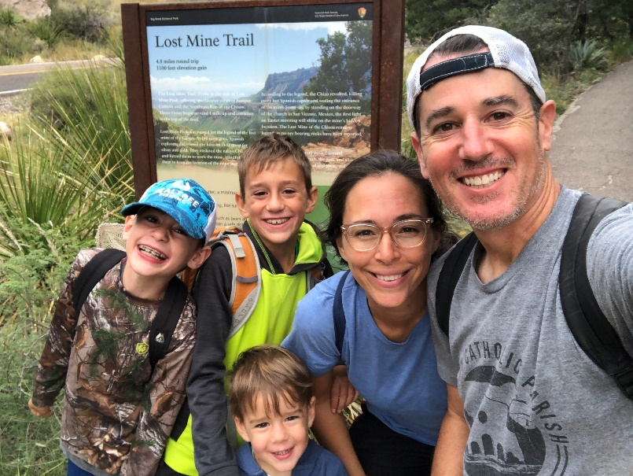
Our Keynote Speaker for both EPIC and Discipleship Week in 2025 is Cooper Ray. He is a dynamic & light-hearted speaker and musician who shares his faith with honesty and passion. Through music, story, humor, and audience participation, Cooper leads groups of all ages to a greater awareness of who they are as Catholic Christians and how to recognize God’s presence in their lives. Over the past 20 years, Cooper has motivated and inspired youth and adults at countless diocesan, parish, and school events across the country and has spoken and led worship at the National Catholic Youth Conference, the National Conference on Catholic Youth Ministry, and Steubenville Youth Conferences, to name a few. His relevant message and crowd interaction can reach a teen all the way in the back row – and he loves working with energetic middle school youth!

Cooper lives in Flower Mound, TX with his wife Laura and three sons, Eli, Keller and Maximus.

We have partnered with Cooper for events in the past such as the Diocesan Youth Conference and Diocesan Work Camp. We are happy to welcome Cooper back to our diocese!

What is the registration fee?
The registration fee for youth participants and adult chaperones is $55/person.

The last day to register is Tuesday, July 15, 2025 at 12:00noon.

Cancellations & Substitutions
Each participant cancellation on or before July 15, 2025 Full Refund
Each participant cancellation after July 15, 2025 No Refund
Each participant substituted between July 15 & August 4, 2025 at 12:00noon* $10
*The last day to request an online substitution is Monday, August 4, 2025 at 12:00noon. Please note, correct t-shirt sizes for substitutions cannot be guaranteed.
**On-site substitutions are ONLY allowed for middle school youth. Please bring their registration paperwork with you to the event. Any rising 6th-8th grade youth can substitute for another, regardless of grade or sex. Adult chaperones CANNOT be substituted or added on-site, in accordance with Diocesan safe environment policies.
***Substitutions must be made within your own parish; we cannot accommodate substitutions where one parish takes a spot from another parish.

What does this registration fee cover?
The participant registration fee covers the following:
- Admission to EPIC
- Lunch, Frozen Snack, & Dinner
- Give Away Item
- T-Shirt

How do I register?
All youth and adults must register through their parish Youth Minister. The registration process includes:

- Registration Form: Print out and distribute the registration form from www.evangelizerichmond.org. A copy should be maintained by the Youth Minister in case of emergency. DO NOT SEND THESE TO THE OFFICE FOR EVANGELIZATION.

- Register Participants via the Online Registration System: If you are the parish Youth Minister, contact the Office for Evangelization to get the password for the online registration system.

- Send payments to the Office for Evangelization (if you did not pay via credit card on the online registration system): Be sure to include your parish/school name along with a list of participants for whom the payment applies. All outstanding registration fees will be invoiced to the parish.

Questions?
Contact us via email (evangelization@richmonddiocese.org) or phone (804-622-5159).

